**COMPUTER NETWORKS LAB**

**Designing and Simulation of Network Topology using Cisco Packet Tracer**

**WEEK 2**

**NAME: VISHWA MEHUL MEHTA**

**SRN: PES2UG20CS389**

**SECTION: F**

**DATE: 29/01/2022**

**Objectives:**

• To understand the purpose of Cisco Packet Tracer.  
• To navigate, choose network and end devices and customize them.  
• To interconnect devices and configure them using simple interface.  
• To become familiar with building topologies in Packet Tracer.  
• To simulate data interactions travelling through a network.

**Task 1 (Demo):**

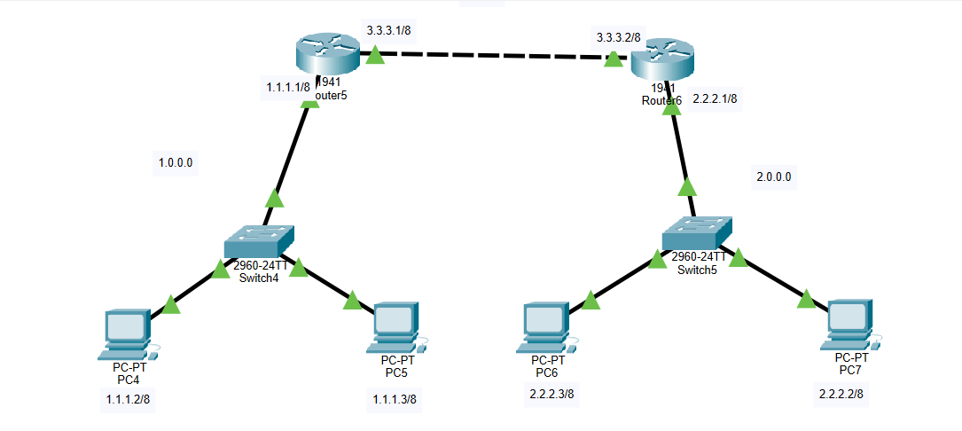

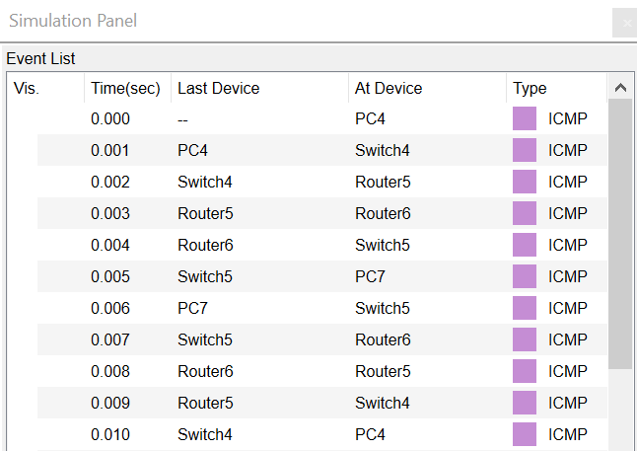

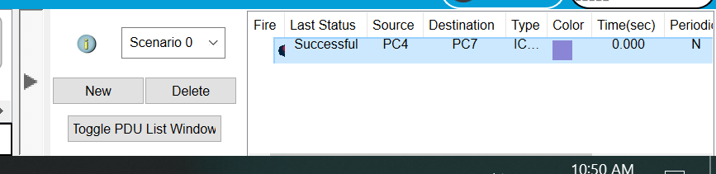

**PC & Router Configuration Details:**

**PC4:**IP Address ---> 1.1.1.2  
Gateway ---> 1.1.1.1

**PC5:**IP Address ---> 1.1.1.3  
Gateway ---> 1.1.1.1

**Router 5:**FastEthernet0/0 ---> 1.1.1.1  
FastEthernet0/1 ---> 3.3.3.1

**Router 6:**FastEthernet0/0 ---> 3.3.3.2  
FastEthernet0/1 ---> 2.2.2.1

**PC6:**IP Address ---> 2.2.2.2  
Gateway ---> 2.2.2.1

**PC7:**IP Address ---> 2.2.2.3  
Gateway ---> 2.2.2.1

**Routing Table Entries:**

**Router Network Next Hop**Router5 2.0.0.0 3.3.3.2  
Router6 1.0.0.0 3.3.3.1

------------------------------------------------------------

**Task 2 (Mandatory for Week-6):**

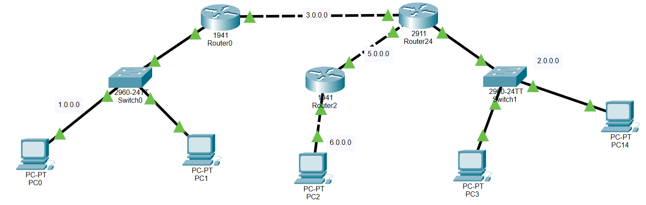

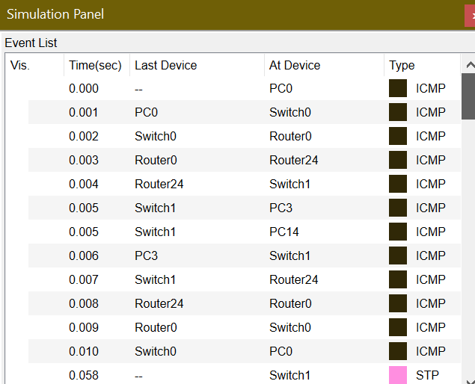

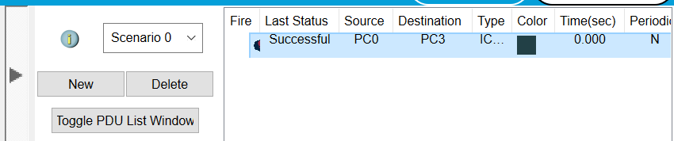

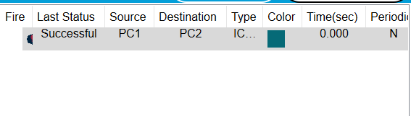

**PC & Router Configuration Details:**

**PC0:**IP Address ---> 1.1.1.2  
Gateway ---> 1.1.1.1

**PC1:**IP Address ---> 1.1.1.3  
Gateway ---> 1.1.1.1

**Router 0:**GigabitEthernet0/0 ---> 1.1.1.1  
GigabitEthernet0/1 ---> 3.3.3.1

**Router 24:**GigabitEthernet0/0 ---> 3.3.3.2  
GigabitEthernet0/1 ---> 5.5.5.2

GigabitEthernet0/2 ---> 2.2.2.1

**Router 2:**GigabitEthernet0/0 ---> 5.5.5.1  
GigabitEthernet0/1 ---> 6.6.6.1

**PC2:**IP Address ---> 6.6.6.2  
Gateway ---> 6.6.6.1

**PC3:**IP Address ---> 2.2.2.2

Gateway ---> 2.2.2.1

**PC14:**IP Address ---> 2.2.2.3  
Gateway ---> 2.2.2.1

**Routing Table Entries:**

Router Network Next Hop

Router 0 2.0.0.0 3.3.3.2

6.0.0.0 3.3.3.2

Router 24 1.0.0.0 3.3.3.1

6.0.0.0 5.5.5.1

Router 2 2.0.0.0 5.5.5.2

1.0.0.0 5.5.5.2